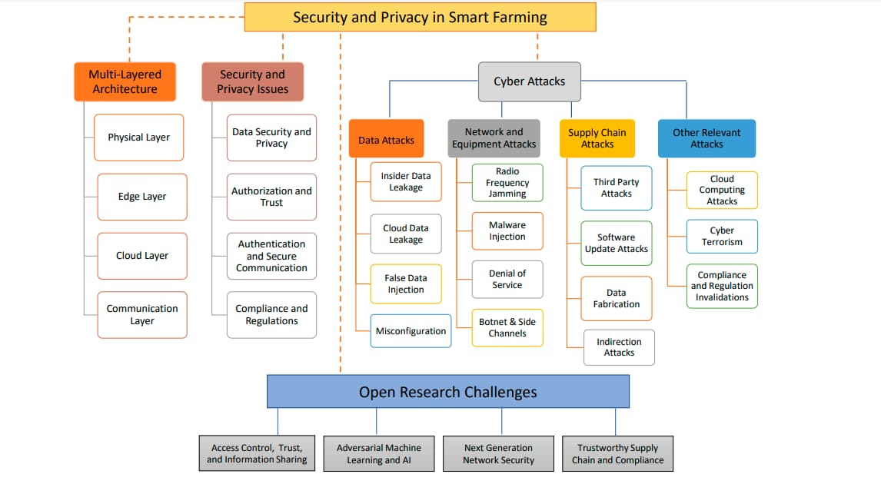***BRAIN STORM FOR SMART CROP PROTECTION SYSTEM USING IOT***